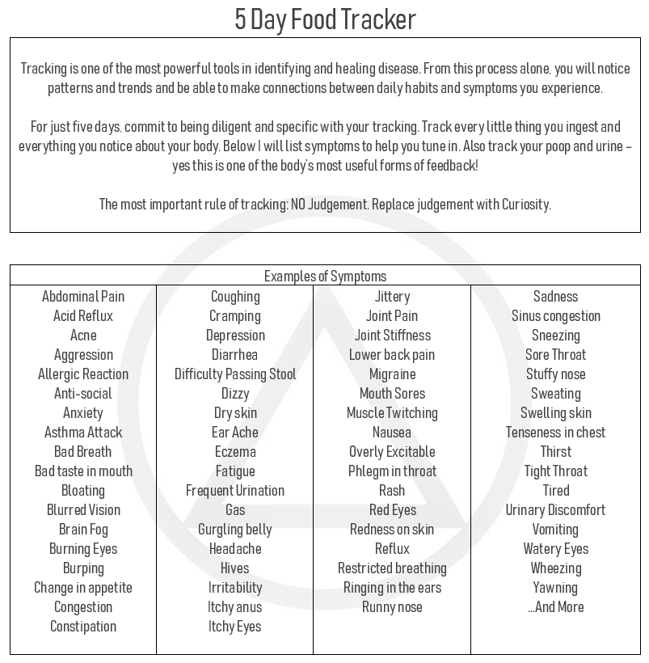

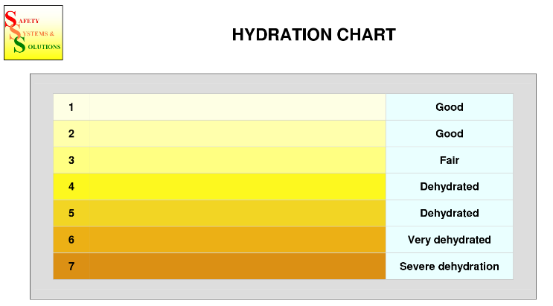
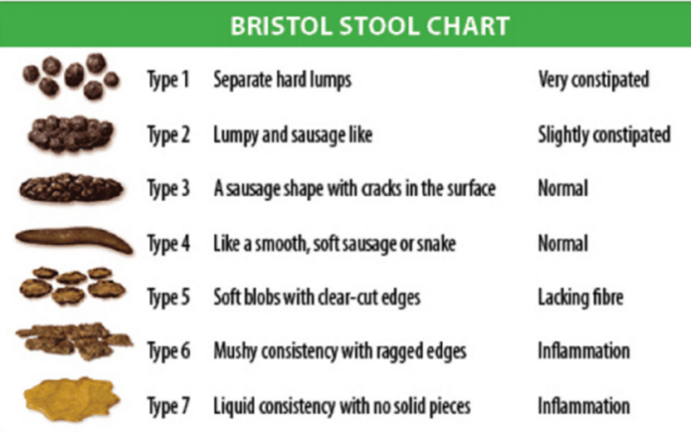

Name: Date:
 | Food & Drink  (Be as specific as possible with ingredients) | What do you notice?  Rate 1 (low) – 10 (high) | Poop  (Use Bristol Stool Chart)
Morning
Mid Morning
Lunch
Afternoon
Dinner
Late Evening

8 oz of water: ☐ ☐ ☐ ☐ ☐ ☐ ☐ ☐ ☐ ☐ ☐ ☐ ☐ ☐ ☐ ☐ ☐ ☐ ☐ ☐ ☐ ☐ ☐ ☐ ☐ ☐ ☐
Bed time previous night: Wake time: Number of times I woke up in the night:
Name: Date:
 | Food & Drink  (Be as specific as possible with ingredients) | What do you notice?  Rate 1 (low) – 10 (high) | Poop  (Use Bristol Stool Chart)
Morning
Mid Morning
Lunch
Afternoon
Dinner
Late Evening

8 oz of water: ☐ ☐ ☐ ☐ ☐ ☐ ☐ ☐ ☐ ☐ ☐ ☐ ☐ ☐ ☐ ☐ ☐ ☐ ☐ ☐ ☐ ☐ ☐ ☐ ☐ ☐ ☐
Bed time previous night: Wake time: Number of times I woke up in the night:
Name: Date:
 | Food & Drink  (Be as specific as possible with ingredients) | What do you notice?  Rate 1 (low) – 10 (high) | Poop  (Use Bristol Stool Chart)
Morning
Mid Morning
Lunch
Afternoon
Dinner
Late Evening

8 oz of water: ☐ ☐ ☐ ☐ ☐ ☐ ☐ ☐ ☐ ☐ ☐ ☐ ☐ ☐ ☐ ☐ ☐ ☐ ☐ ☐ ☐ ☐ ☐ ☐ ☐ ☐ ☐
Bed time previous night: Wake time: Number of times I woke up in the night:
Name: Date:
 | Food & Drink  (Be as specific as possible with ingredients) | What do you notice?  Rate 1 (low) – 10 (high) | Poop  (Use Bristol Stool Chart)
Morning
Mid Morning
Lunch
Afternoon
Dinner
Late Evening

8 oz of water: ☐ ☐ ☐ ☐ ☐ ☐ ☐ ☐ ☐ ☐ ☐ ☐ ☐ ☐ ☐ ☐ ☐ ☐ ☐ ☐ ☐ ☐ ☐ ☐ ☐ ☐ ☐
Bed time previous night: Wake time: Number of times I woke up in the night:
Name: Date:
 | Food & Drink  (Be as specific as possible with ingredients) | What do you notice?  Rate 1 (low) – 10 (high) | Poop  (Use Bristol Stool Chart)
Morning
Mid Morning
Lunch
Afternoon
Dinner
Late Evening

8 oz of water: ☐ ☐ ☐ ☐ ☐ ☐ ☐ ☐ ☐ ☐ ☐ ☐ ☐ ☐ ☐ ☐ ☐ ☐ ☐ ☐ ☐ ☐ ☐ ☐ ☐ ☐ ☐
Bed time previous night: Wake time: Number of times I woke up in the night:

